Paper Review on

(Driving Event Detection and Driving Style Classification using Artificial Neural Networks)

Patrick Brombacher, Johannes Masino, Michael Frey, Frank Gauterin

**Paper's Background-** In the paper titled “Driving Event Detection and Driving Style Classification using Artificial Neural Networks”, the authors feel that knowledge about the behavior of the driver is a crucial factor, because it not only affects them but also the environment. The authors think that this has widespread applications, among which Advanced Driver Assistance Systems is one. A novel algorithm is proposed to accurately predict a driver’s driving style. The model is based on the identification of driving maneuvers and the classification of the driving style for these events using Artificial Neural Networks(ANN). The model has various test cases on which the driver’s trip is evaluated. The measuring device is based on Raspberry pie. The output values (outputs of testcases) are then summed to give the final value which decides the driving style of the driver. The sensors used are smartphones sensors as they provide a powerful platform with both multiple sensors and the possibility to implement an algorithm for on-line calculations. The driving style can either be classified continuously or based on individual events of a trip, such as accelerations or curves, Dynamic Warping is used for individual events of trip and Advanced Driver Assistance Systems (ADAS) is used for continuous classification. The authors use self-developed measurement device to acquire data from gps sensor and inertial sensors under real driving conditions. The Raspberry pie is attached to following sensors Inertial module LSM9DS1, GPS module built around the MTK 3339 chipset. The driving style is then calculated by the ANNs after taking feature vectors as the input from the statistical values obtained from the sensor data.

**Main Contribution**

Block Diagram

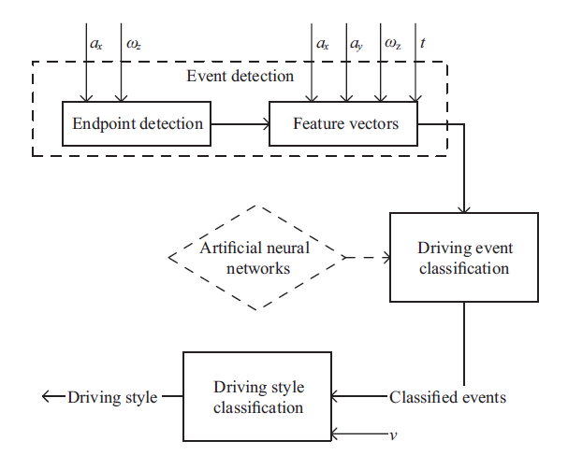

The algorithm presented is a three-step process as shown in the block diagram.

In the first step, the start and end points of longitudinal and latitudinal events are detected based on the thresholds of longitudinal acceleration and the yaw rate.

In the second step, all detected maneuvers are classified into either of the six longitudinal or four latitudinal events by two ANNs, that are trained in advance.

In the last step, based on the thresholds, the algorithm calculates the driving style of the driver.

The three steps are mentioned below:

## **Endpoint Detection**

After the import and pre-processing of all data from a trip, the endpoint detection algorithm identifies start and end points of lateral driving maneuvers, such as turns, and longitudinal driving maneuvers, such as accelerations and decelerations using a threshold-based approach.

## **Driving Event Classification**

In the second step of our algorithm, the detected events are classified using two ANNs. The calculated feature vectors of the detected events serve as inputs for the classification. The network classifies the respective event into different classes. Longitudinal driving maneuvers are distinguished in two categories accelerating and braking, both defensive and sporty resulting into four different classes. The lateral events are divided into light, medium and sharp turns based on the yaw rate, each classified as defensive or sporty, which leads to six classes.

**Driving Style Classification**

In the Third step the algorithm classifies the driving style based on the detected events. The score of each event is calculated and then added. The final sum gives us the idea about the driving style of the driver. The overall score is calculated as the average of all the scores because turns cannot be exclusively classified into one of the three sharp categories. The higher the score the more defensive is the driving of the driver.

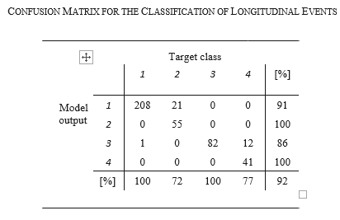

The above table shows the accuracy of the predictions.

**Importance of the Contribution**

In the paper, the authors present a model that can detect longitudinal and lateral driving maneuvers from inertial sensor data. The detected events are classified by two ANNs, into defensive and sporty driving maneuvers; using the event classification, the algorithm calculates an overall driving style classification score to rate the driving style into five categories: Very Sporty, Sporty, Normal, Defensive, Very Defensive.

Since the paper helps label the driving style of a person, the insurance industry can use the predictions to charge the drivers based on their respective driving styles and hence people with defensive style can save on their insurance premiums. If the approach mentioned in the paper is well implemented, it could revolutionize the entire car insurance industry and present a novel way to charge customers.

**Gaps and potential future work**

Accurate classification cannot be guaranteed if the number of events detected are not enough.

Adding to that, traffic jams lead to a major distortion because numerous defensive acceleration events are detected and prevent an accurate driving style classification.

The model could further be extended to detect areas where traffic jams occur and remove them as events influencing the driving style, leading to a better and more accurate prediction.

Also, the data about the steering wheel angle and the throttle or brake pedal to allow for a more accurate endpoint detection. The number of classes providing more information about the driving class, could be increased further improving the accuracy of the algorithm.